Week-03-Decision Making and Branching -if ,if…else and nested if…else, if else…if, switch case

Week-03-01-Practice Session-Coding

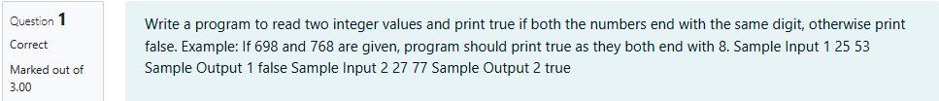

Source Code

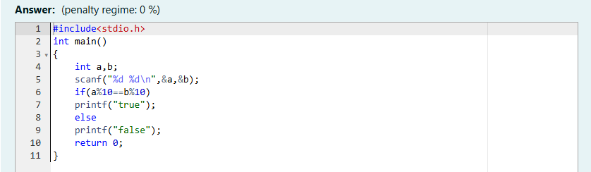

Result

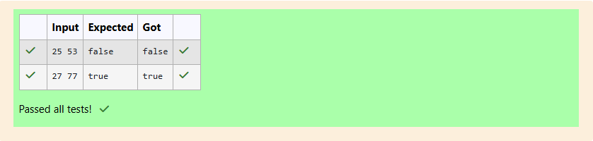

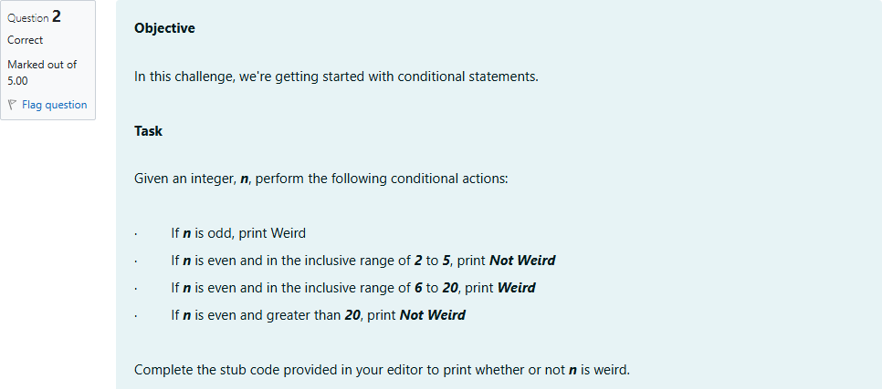

Source Code

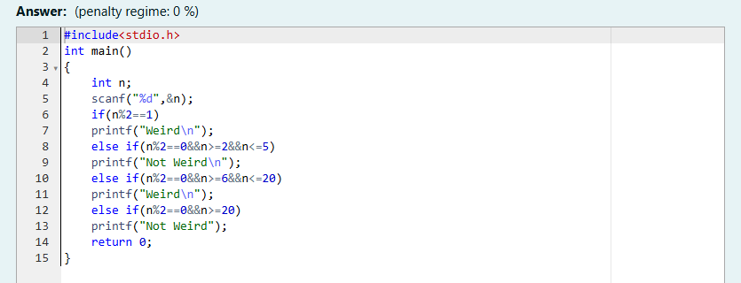

Result

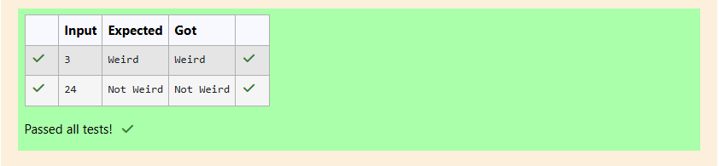

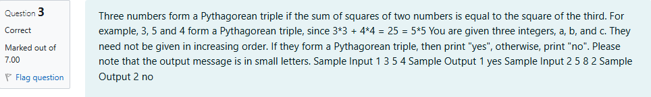

Source Code

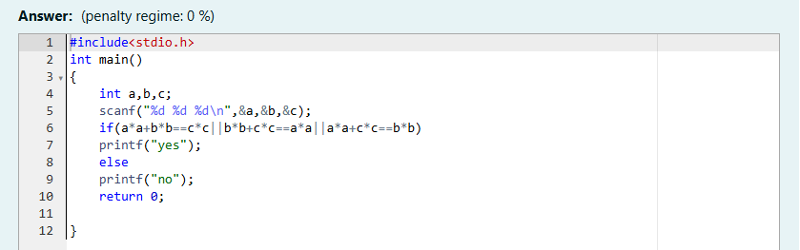

Result

